Cheetah Dash Board Pin-connector
Front view:
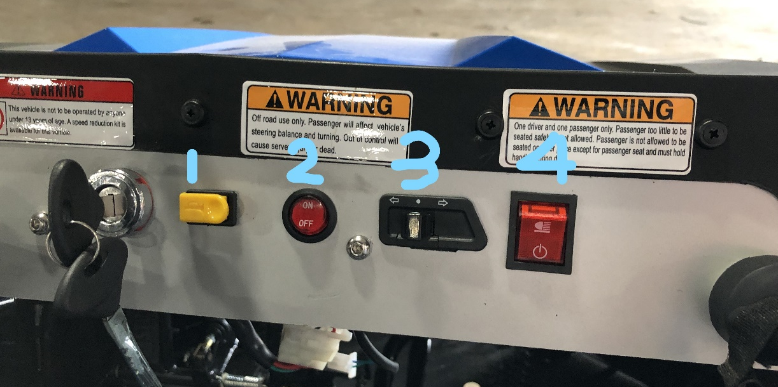

Behind view:

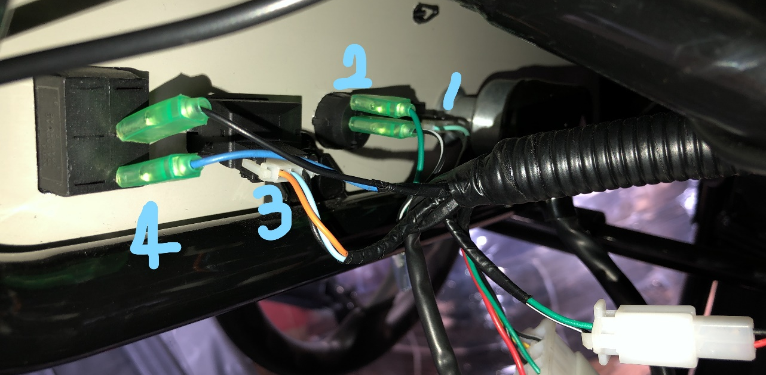

Please make sure the pin-connector were connected correctly as in the picture.

